GLY 4310C

LAB 9 METAMORPHIC ROCKS, PART 1 LOWER-GRADE

REGIONAL METAMORPHICS

Slate, Phyllite, “Greenstone”, and Schist

**Sample 77. Gray Slate**

Slates are usually formed by the metamorphism of shale. They possess slaty (note spelling) cleavage and hence can be split into slabs and thin plates. Slates are usually named for their color in hand specimen. The colors are due to various impurities. Spotted slates are bumpy due to the formation of incipient porphyroblasts. Slates generally have a dull, earthy appearance in hand specimen.

Aphanitic - obvious slaty cleavage. One "spot" due to incipient porphyroblast.

Some video for the hand specimen: <https://www.youtube.com/watch?v=IwCCz2QF5W8>

For more information: <https://www.alexstrekeisen.it/english/meta/slate.php>

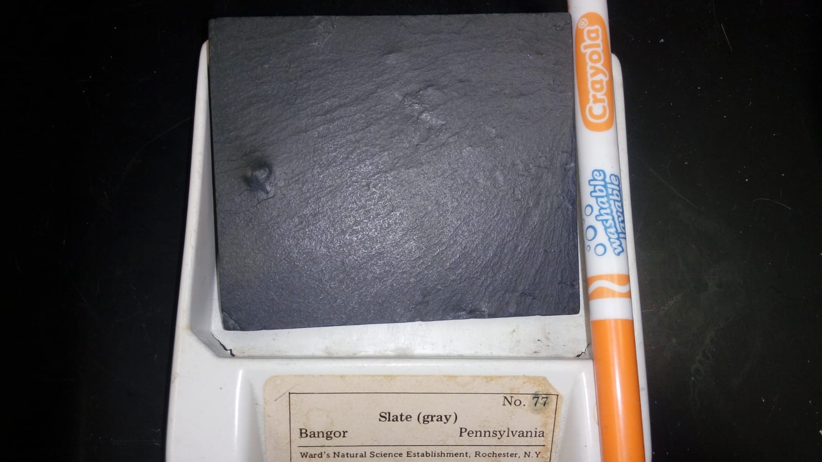

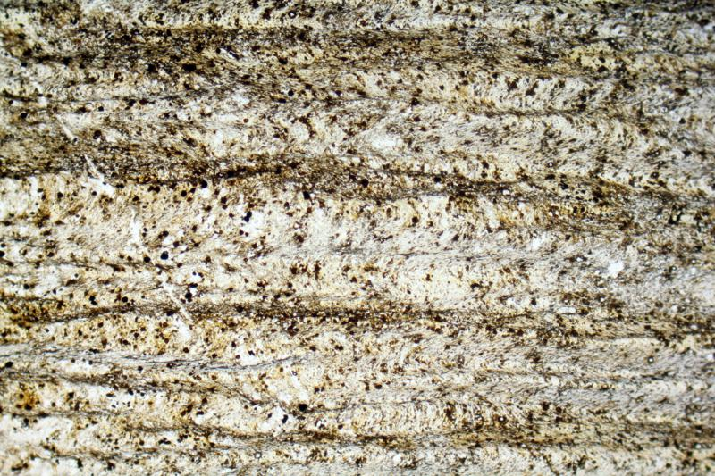

Crenulation cleavage in a slate. PPL image, 2x (Field of view = 7mm)

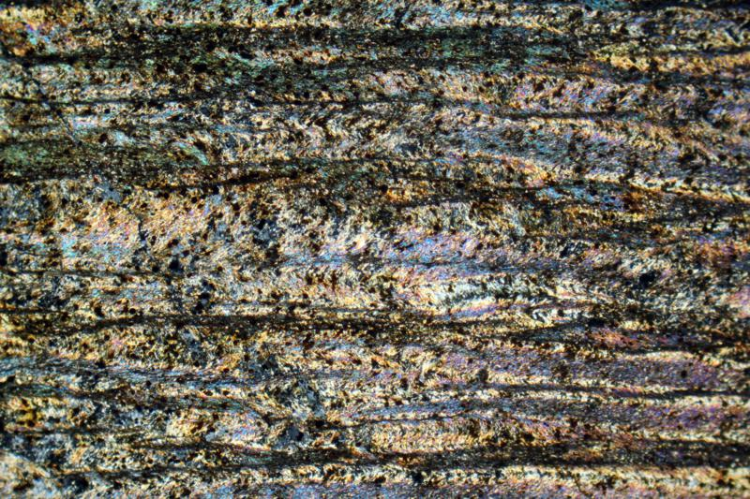

Crenulation cleavage in a slate. XPL image, 2x (Field of view = 7mm)

**Sample 77. Purple Slate**

Slates are usually formed by the metamorphism of shale. They possess slaty (note spelling) cleavage and hence can be split into slabs and thin plates. Slates are usually named for their color in hand specimen. The colors are due to various impurities. Spotted slates are bumpy due to the formation of incipient porphyroblasts. Slates generally have a dull, earthy appearance in hand specimen.

Aphanitic - obvious slaty cleavage.

Some video for the hand specimen: <https://www.youtube.com/watch?v=IwCCz2QF5W8>

For more information: <https://www.alexstrekeisen.it/english/meta/slate.php>

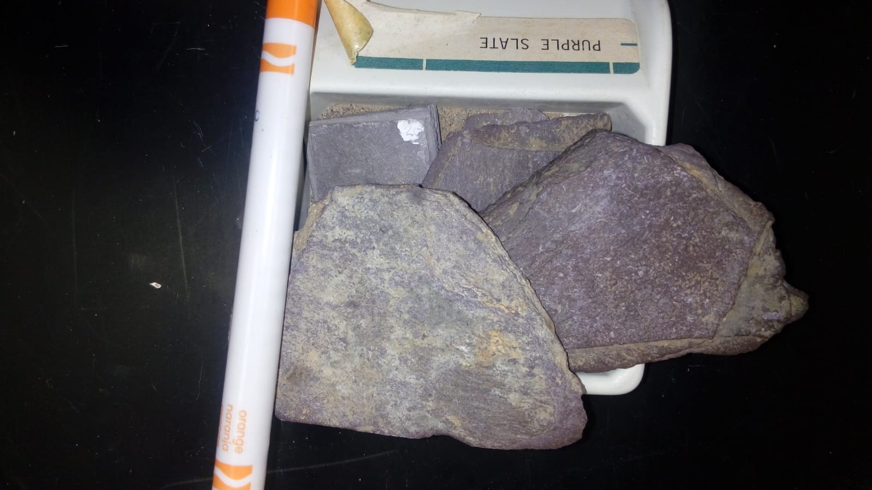

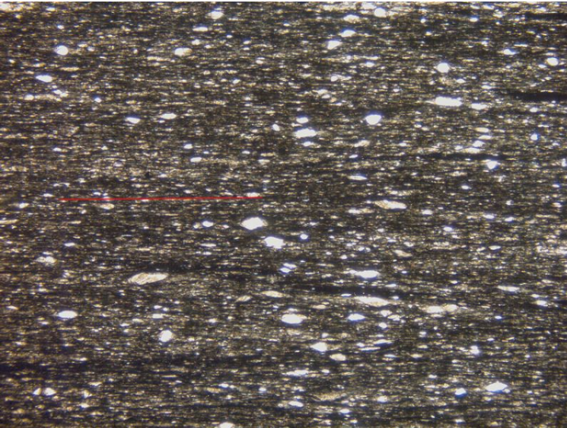

*Thin section image of purple slate from Bethesda, North Wales. The red line represents the orientation of the slaty fabric formed by the growth of mica. The larger, bright grains are detrital mica and quartz from the original sediment. Width of image 4.5 mm.*

**Sample 78. Phyllite**

Phyllites are metamorphic rocks intermediate in composition between slate and mica schist. Minute crystals of sericite and chlorite impart a silky sheen to the cleavage surface (or surface of schistoscity). Phyllites often exhibit corrugated cleavage surfaces. Spotted phyllites are bumpy due to the formation of incipient porphyroblasts.

Aphanitic matrix - 97%, displays lamination and silky sheen.

Pyrite - 2%, ehd, 0.5 mm, occur in layers.

Quartz - 1%, anh, smoky translucent,

1.5 mm, rounded.

One specimen displays lineation in the form of

subparallel to parallel surface striations.

Hand sample video: <https://www.youtube.com/watch?v=NGjpoHoh7hM>

For more information: <https://www.alexstrekeisen.it/english/meta/phyllite.php>

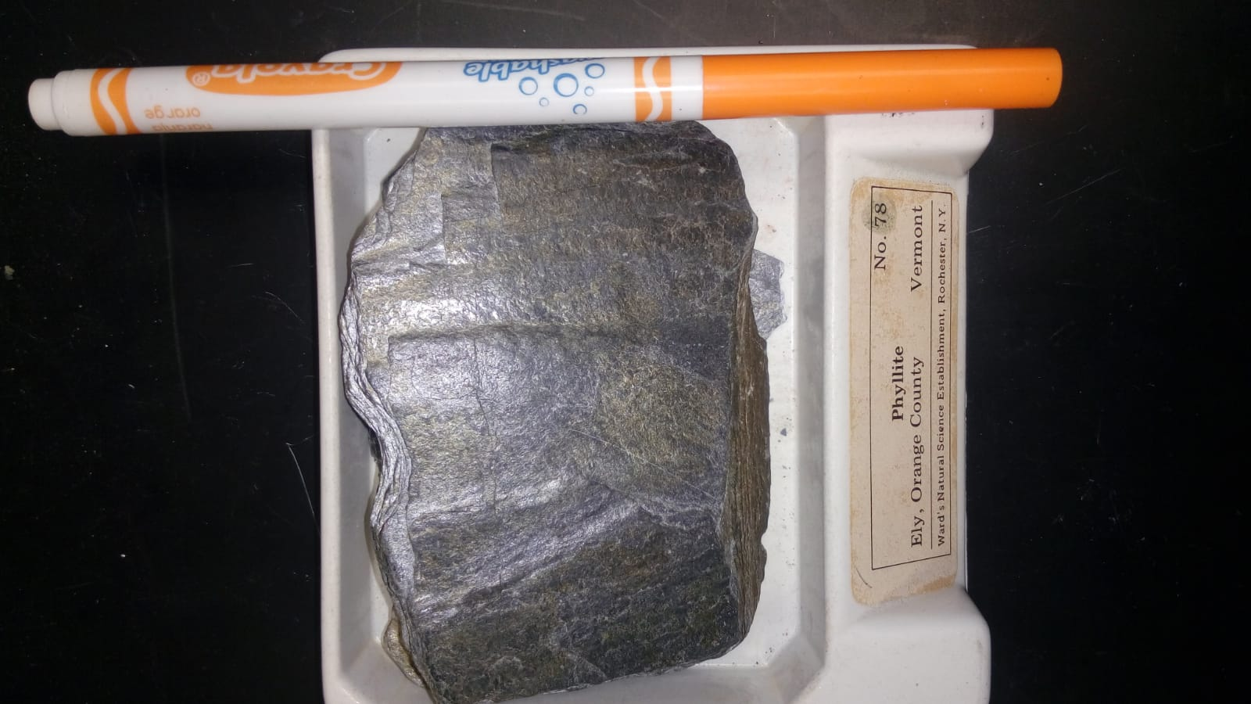

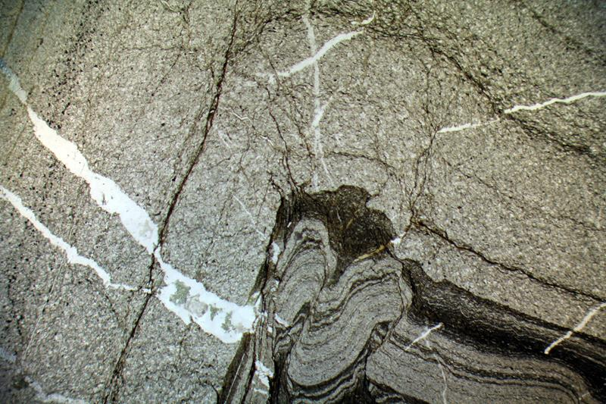

Phyllite with mica-rich band with Crenulation and quartz-rich band (without Crenulation). Gerrei, Sardinia (Italy). PPL image, 2x (Field of view = 7mm)

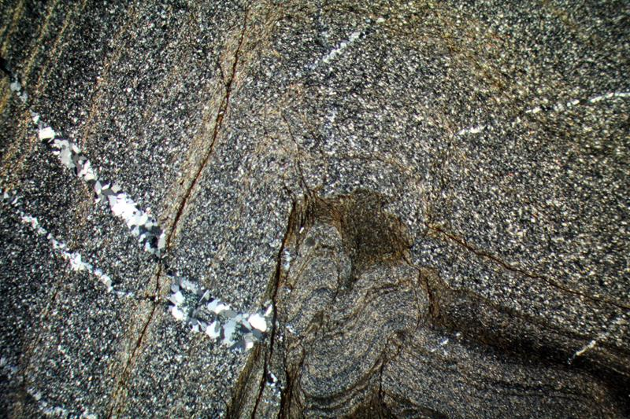

Phyllite with mica-rich band with Crenulation and quartz-rich band (without Crenulation). Gerrei, Sardinia (Italy). XPL image, 2x (Field of view = 7mm)

**Sample 79. Mica Schist**

Schist is a strongly foliated crystalline rock which can be readily split into thin flakes or

slabs due to the well-developed parallelism of more than 50% of the minerals present. Mica and actinolite schists are typical greenschist facies rocks. The muscovite of the mica

schist is commonly found in metamorphosed sedimentary rocks.

Dark Layers 60%, anh micas, thin bands 2.5

mm, black to green, trachytoid behavior

around felsics.

Muscovite: 30%

Biotite: 15%

Chlorite: 15%

Hand sample video: <https://www.youtube.com/watch?v=nJLrP-T0DL0>

For more information: <https://www.alexstrekeisen.it/english/meta/garnetmicaschist.php>

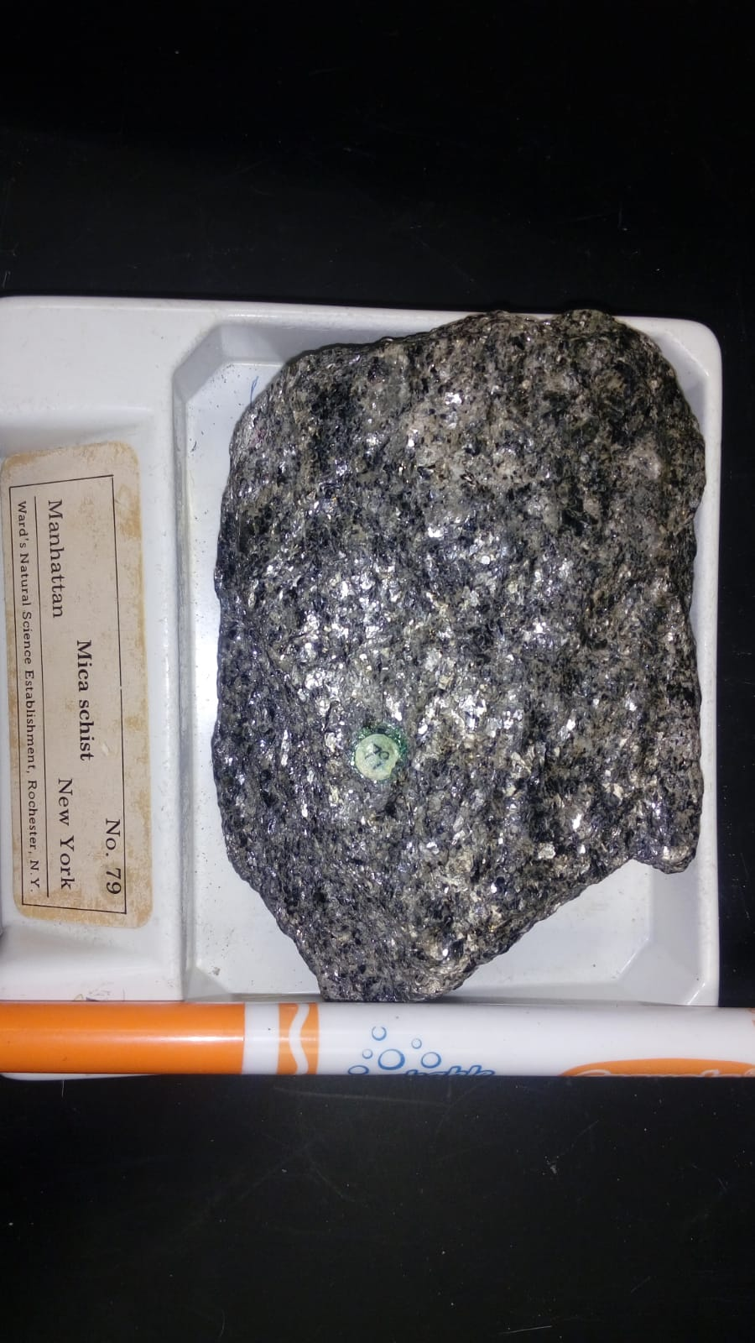

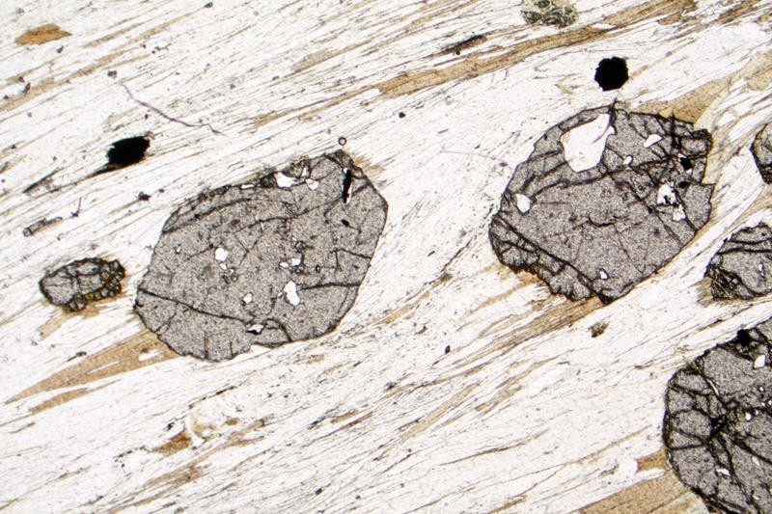

Garnet and muscovite-biotite layers in a Garnet mica-schist. PPL image, 2x (Field of view = 7mm)

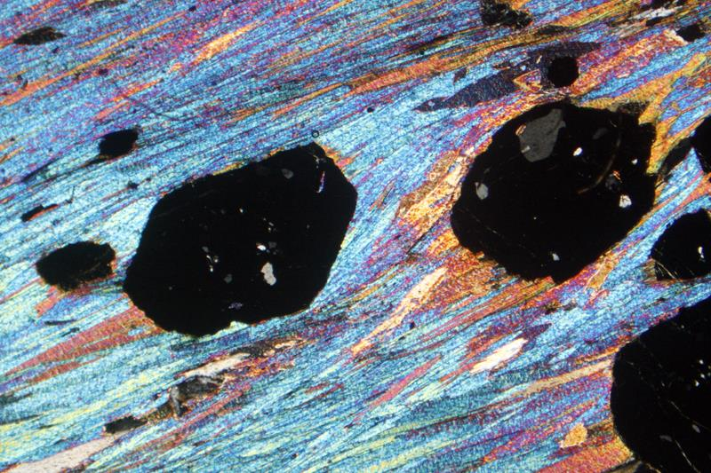

Garnet and muscovite-biotite layers in a Garnet mica-schist. XPL image, 2x (Field of view = 7mm)

**Sample 81. Stilpnomelane schist**

Stilpnomelane schist probably formed in a moderate to high pressure rocks. All the specimens are part of the Franciscan formation. This formation contains sediments (and the metamorphic product of those sediments) from the floor of the Pacific, scrapped off as the Pacific was subducted. Stilpnomelane is usually regarded as a low-grade metamorphic mineral but here it occurs with garnet, sometimes regarded as a high-grade mineral. This is probably the result of high pressure, low-temperature conditions.

Dark layer: Stilpnomelane: 67-80%, anh, grayblack, 0.5 mm

Light layer: Quartz: 20-30%

For more information: <https://www.ucl.ac.uk/~ucfbrxs/MoreMinerals/Stilpnomelane.html>

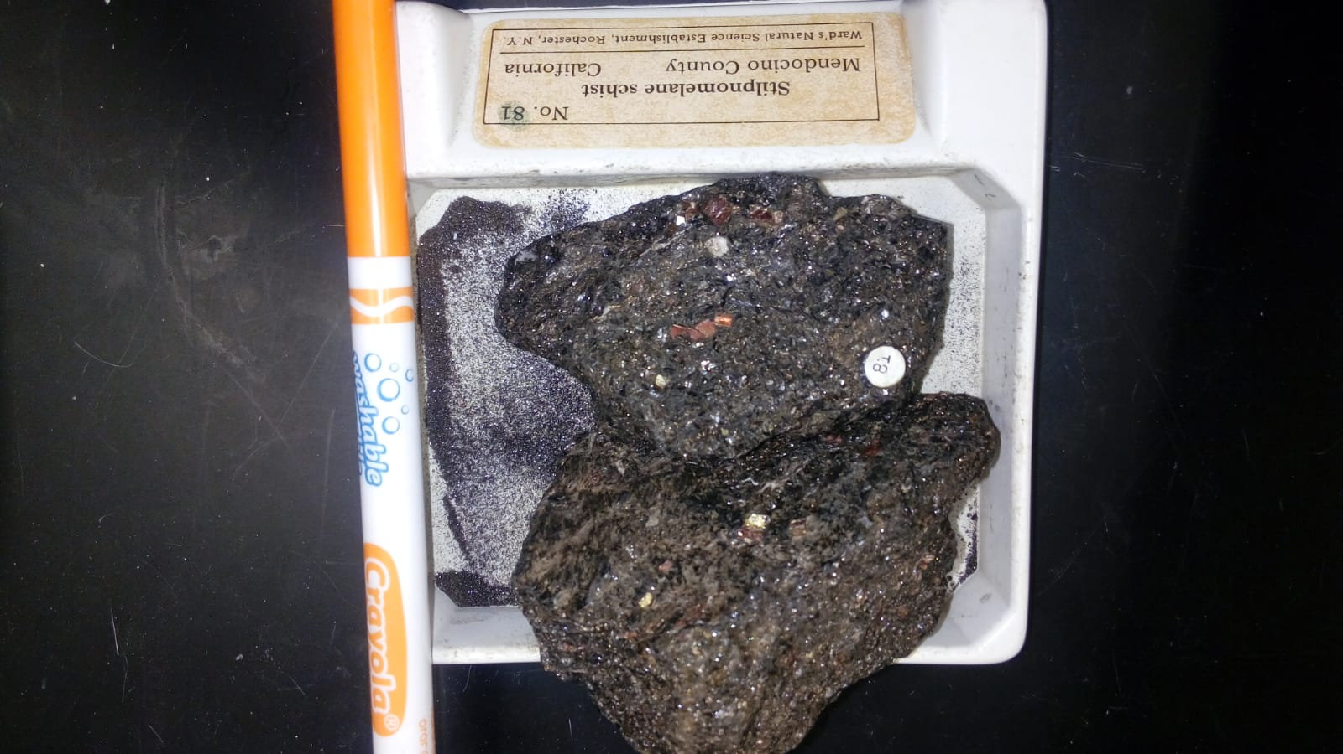

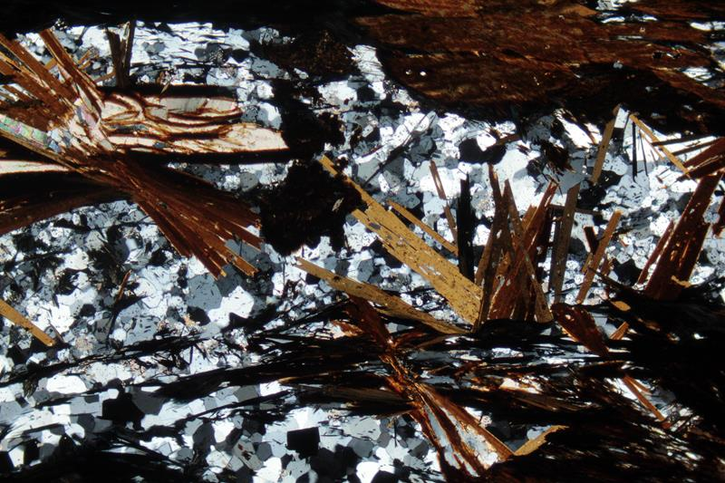

Radiating Stilpnomelane crystals. Laytonville quarry, California. PPL image, 2x (Field of view = 7mm)

<https://www.youtube.com/watch?v=ZGDTmbohZHs>

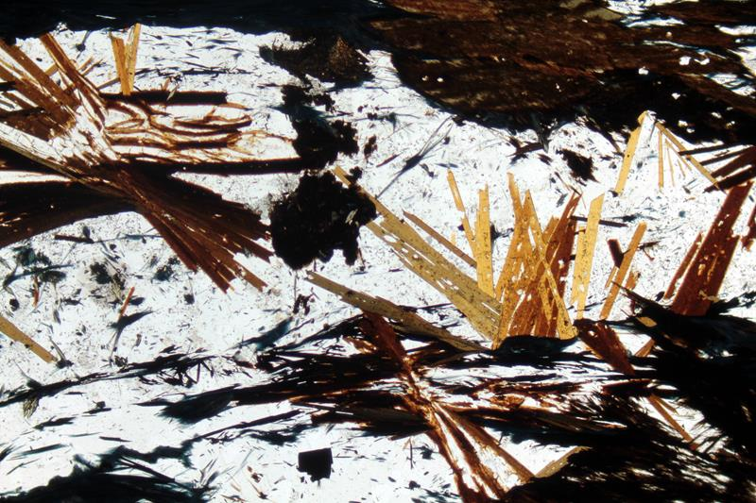

Radiating Stilpnomelane crystals. Laytonville quarry, California. XPL image, 2x (Field of view = 7mm)

<https://www.youtube.com/watch?v=fH_UkzdmEXs>

**Sample 84. Andalusite (chiastolite) slate**

Andalusite of the three Al2SiO5 polymorphs. Occurs as thick, nearly square prisms in schists, gneisses, and hornfels. It forms at medium temperature and pressures of a regionally metamorphosed sequence. Also, characteristic of contact-metamorphosed argillaceous rocks. Chiastolite is an opaque variety of andalusite containing black carbonaceous impurities arranges in a regular manner so that a section normal to the long axis of the

crystal shows a black Maltese cross. The cross grows as the result of the crystal pushing the impurities aside as it grows in metamorphosed

carbonaceous shales.

Andalusite: 5-10%

Pyrite: 5%

Graphite: 85-90%

For more information: <http://www.northern-england-eology.co.uk/pages/page73chiastolite-slate.htm>

<https://www.alexstrekeisen.it/english/meta/andalusiteschist.php>

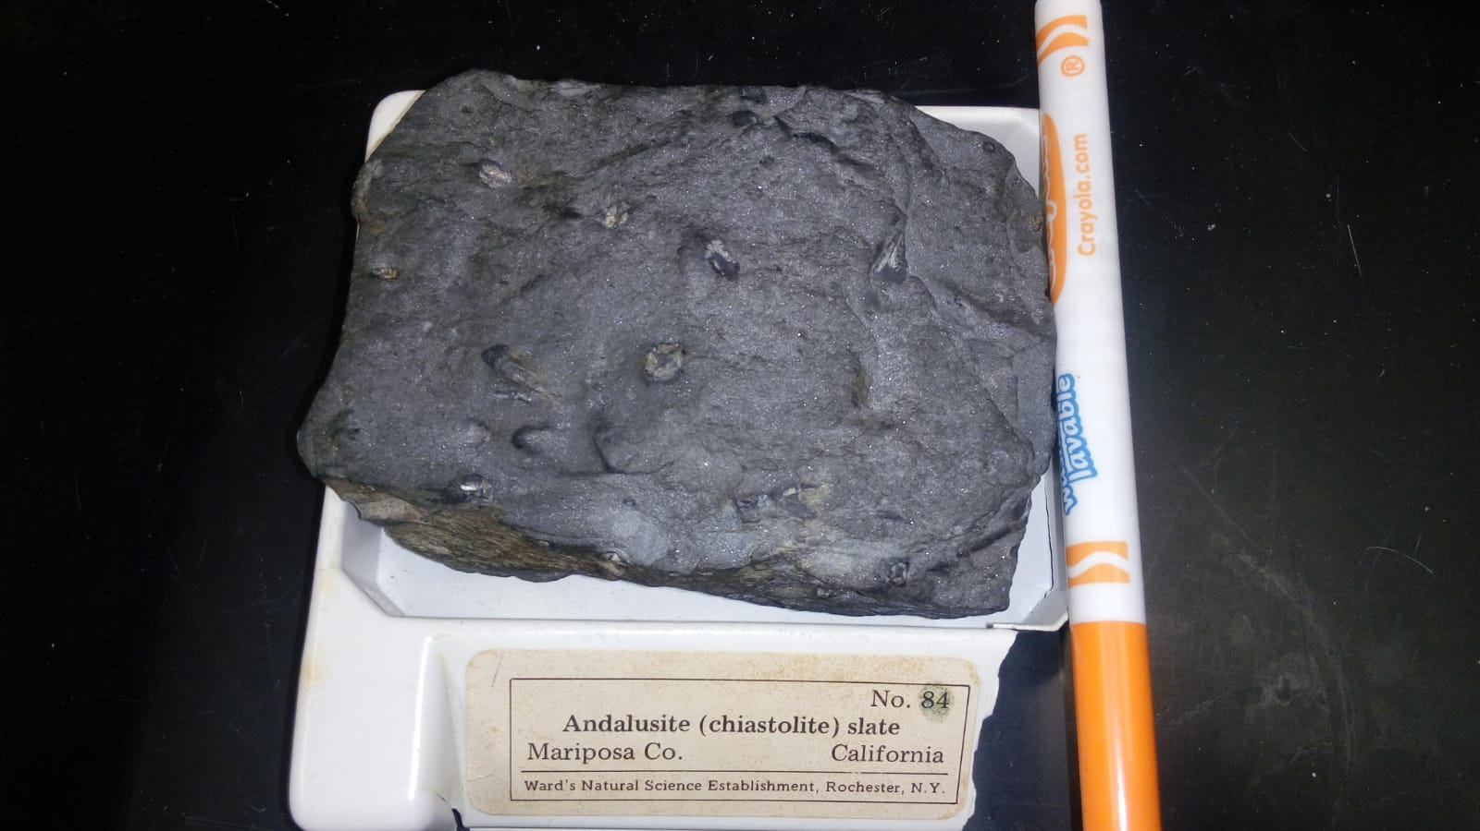

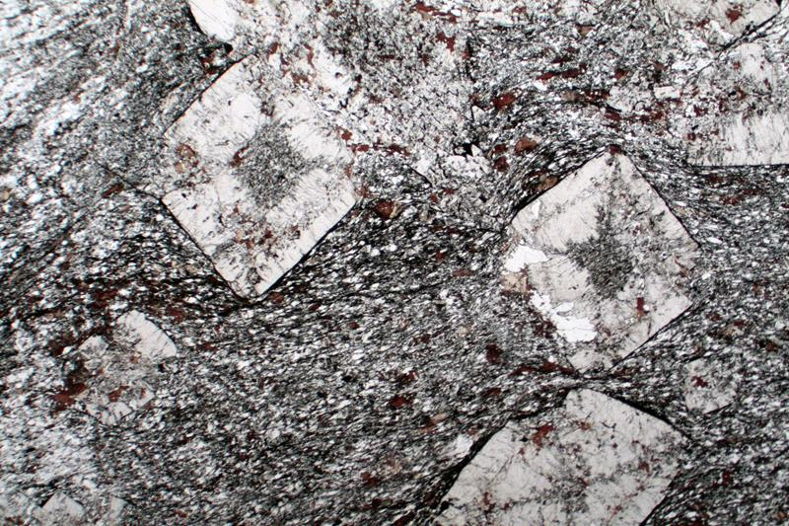

Chiastolite crystals in a slate from Karakorum. PPL image, 1x (Field of view = 9mm).

<https://www.youtube.com/watch?v=oEKWH_D8wDw>

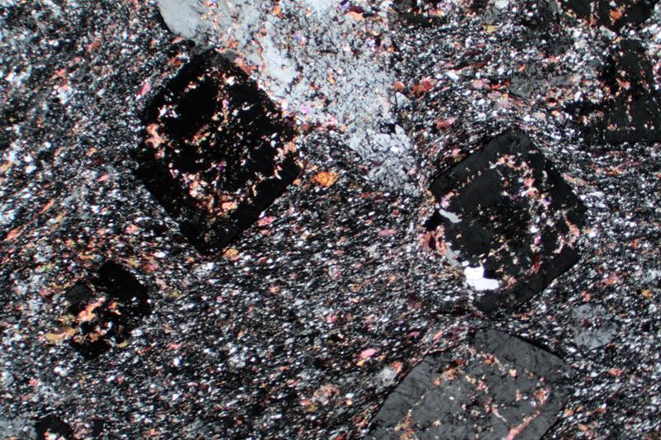

Chiastolite crystals in a slate from Karakorum. XPL image, 1x (Field of view = 9mm)

<https://www.youtube.com/watch?v=VFlEozt6sMc>

**93. Actinolite schist**

Actinolite schists is typical greenschist facies rocks. Actinolite is usually found in metamorphosed igneous rocks. Actinolite is A bright to grayish-green mineral of the amphibole group. The more iron rich members of the tremolite series are actinolites. Symbol: Ac. Formula: Ca2(Mg,Fe)5Si8O22(OH)2. May be asbest-iform, but often occurring as fibrous, radiated, or columnar forms in metamorphics rocks (usually schists) or altered igneous rocks.

Talc: 5%

Chlorite: 10-15%

Actinolite: 80-85%

For more information: <https://www.alexstrekeisen.it/english/meta/actinolite.php>

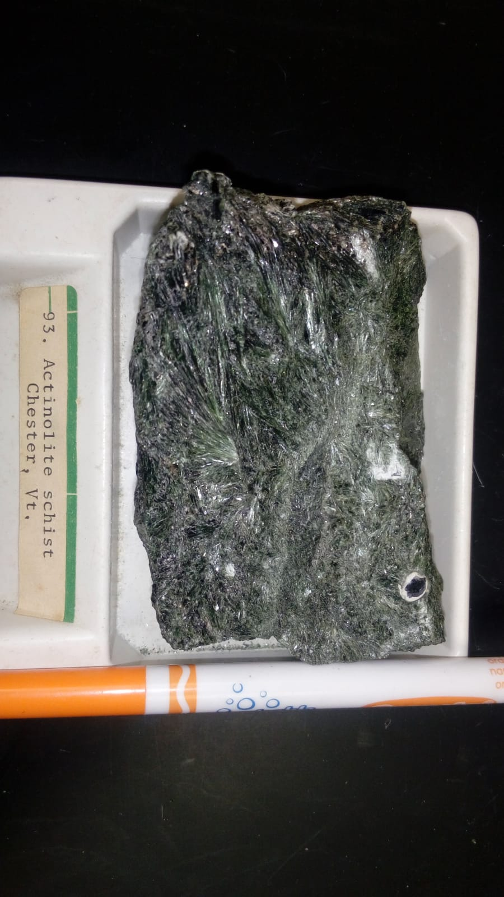

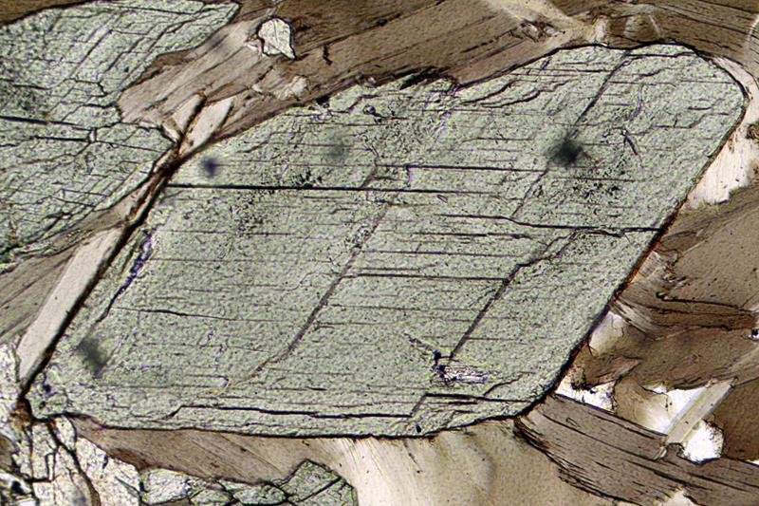

Basal section of actinolite. Anzasca valley, Piedmont, Italy. PPL image, 20x (Field of view = 1mm)

<https://www.youtube.com/watch?v=D4Gm7okGK2I>

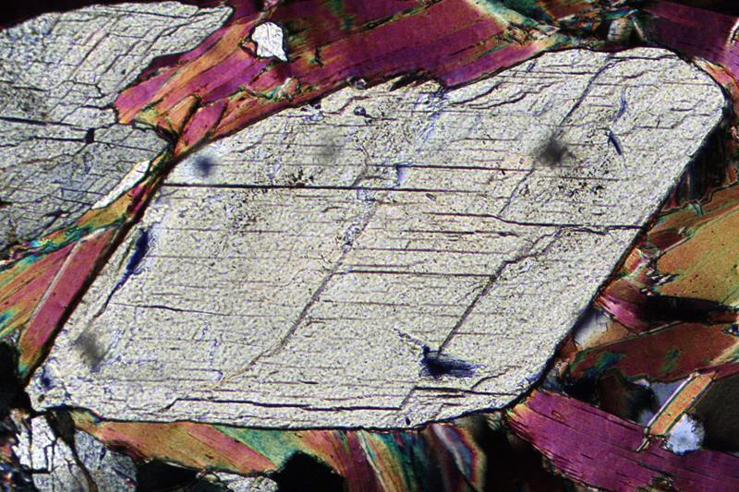

Basal section of actinolite. Anzasca valley, Piedmont, Italy. XPL image, 20x (Field of view = 1mm)

**94.** **Cummingtonite schist**

Cummingtonite schist represents a slightly higher grade of metamorphism, the amphibolite facies. Cummingtonite is a brownish mineral of the amphibole group. Formula: (Mg,Fe)7Si8O22(OH)2.

It contains more iron than anthophyllite and may contain zinc or manganese. There is a solid solution series between cummingtonite and the iron-rich variety grunerite. It often occurs in metamorphic rocks as lamellae or fibers.

Dark Layers: mainly aphanitic, 34-54%, black green and pyrite: 5%

Light layers: Quartz: 1%, Cummingtonite: 40-60%

For information: <http://www.science.smith.edu/geosciences/petrology/petrography/cummingtonite/cummingtonite.html>

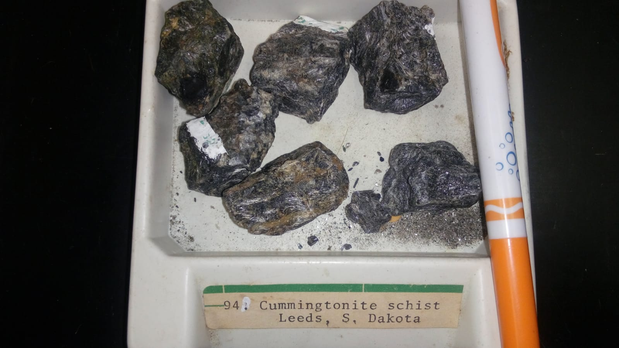

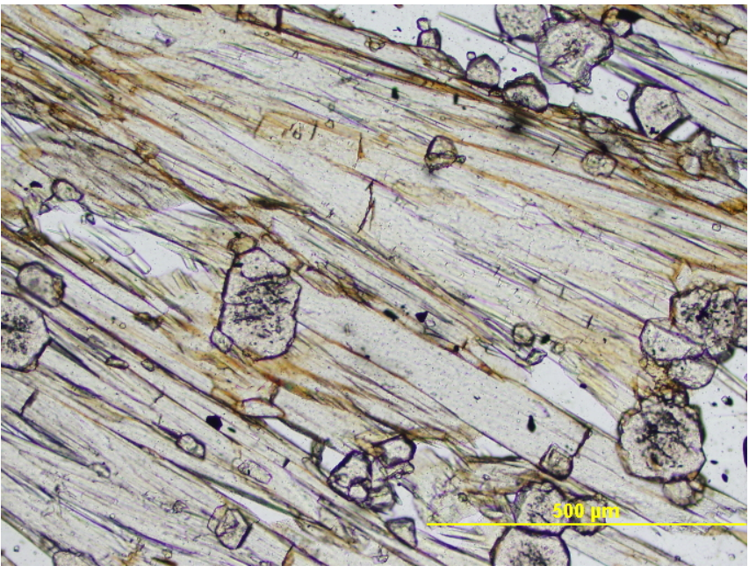

Photomicrograph of cummingtonite in plain light, 10x magnification. Note light brown pleochorism.

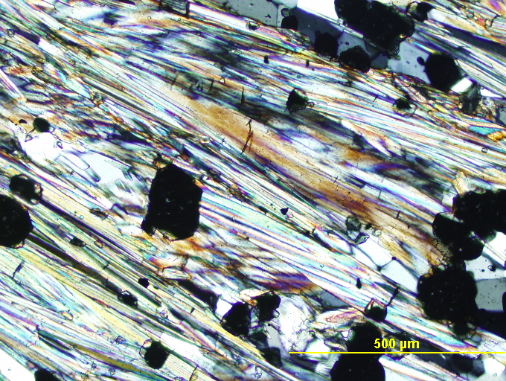

Photomicrograph of cummingtonite in XPL, 10x magnification.

**96. Glaucophane schist**

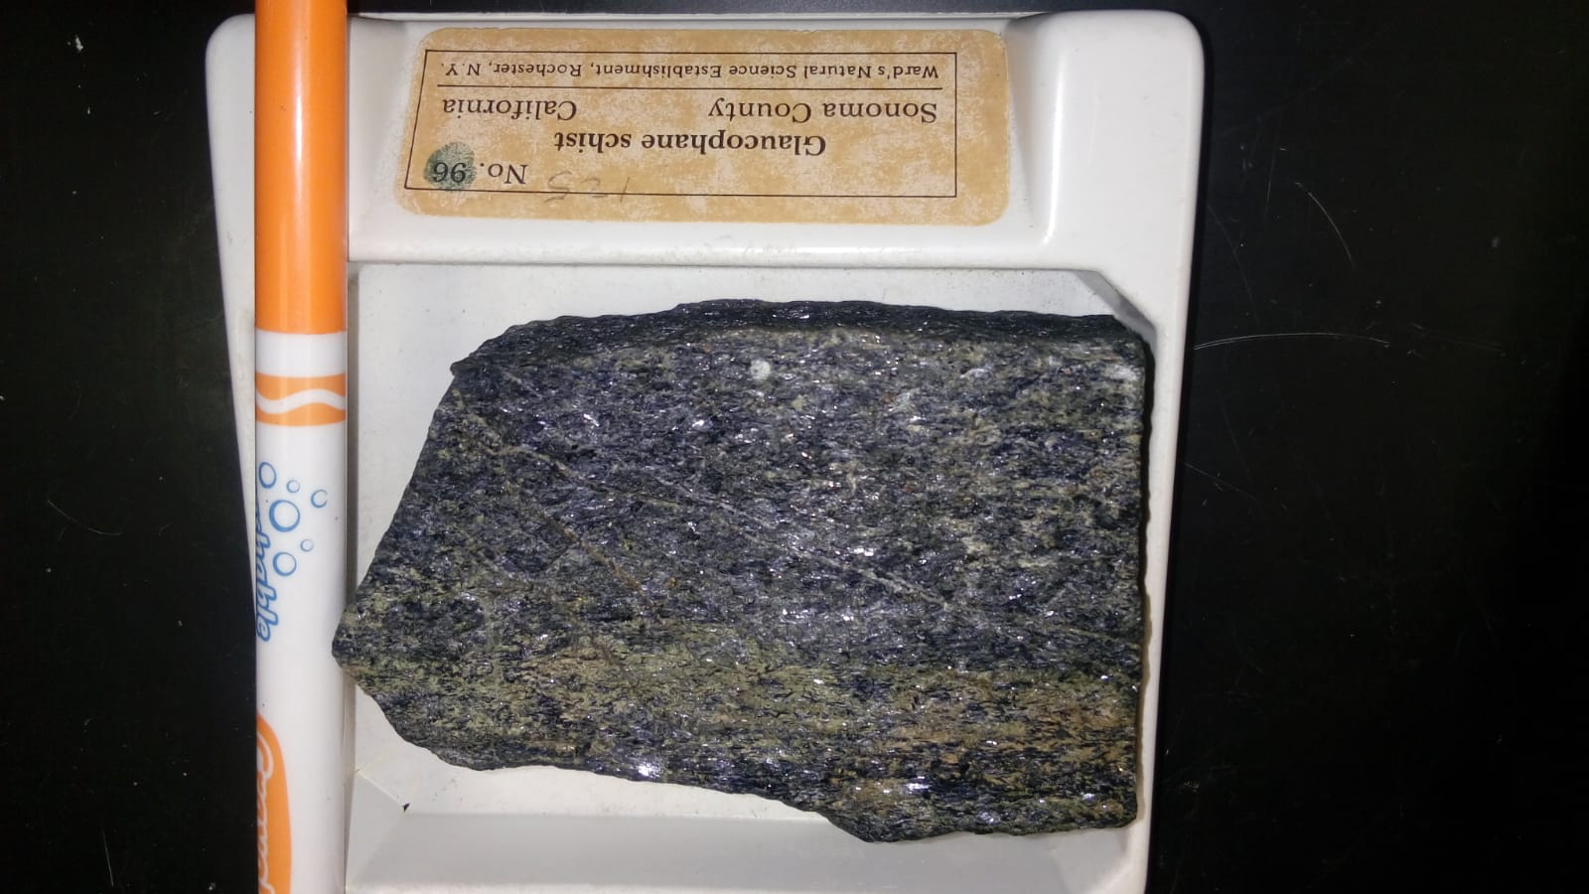

Glaucophane schist is typical of moderate to high pressure rocks seen on the oceanic side of

the eugeosyncline. Medium grained, schistose,

non-fissile.

Quartz: 6-14%

Pyrite: 1%

Glaucophane: 75-95%

Other Minerals: Garnet 3-10%,

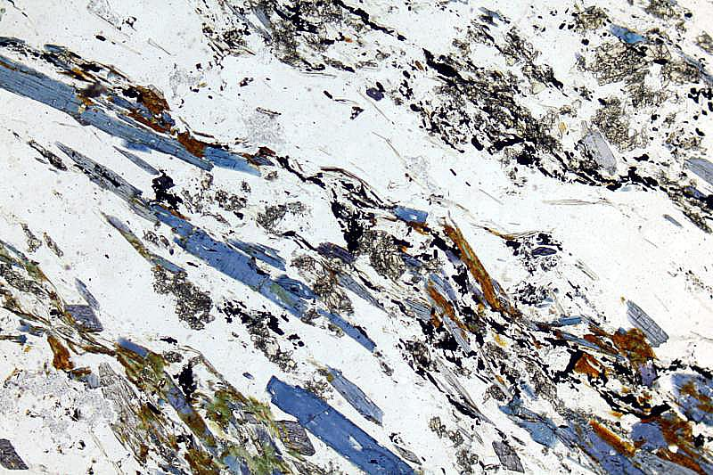

Glaucophane crystals in a quartz schist. PPL image, 2x (Field of view = 7mm)

<https://www.youtube.com/watch?v=OpfCGUtF6s8>

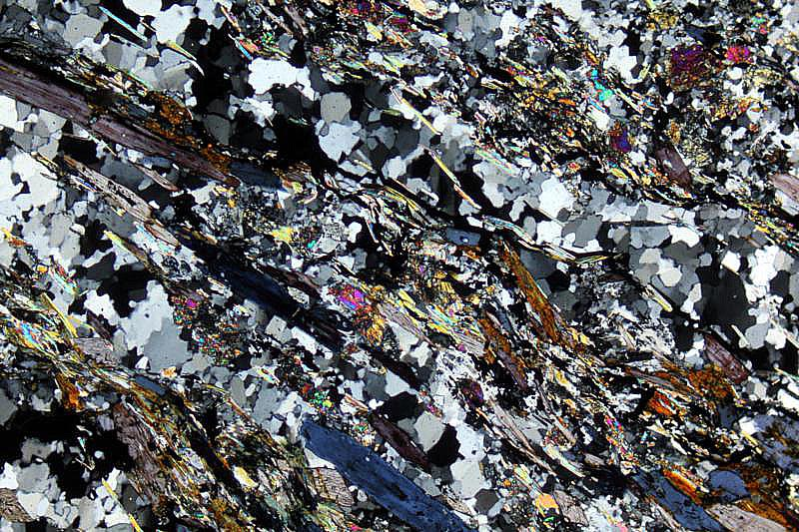

Glaucophane crystals in a quartz schist. XPL image, 2x (Field of view = 7mm)

<https://www.youtube.com/watch?v=NyOw14Kc4TQ>

**Other rock specimens.**

**Kyanite schist**

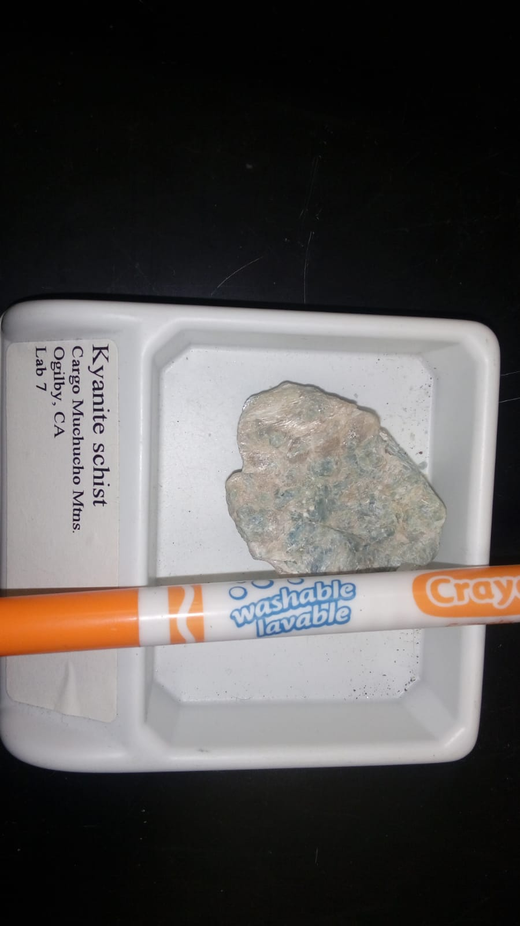

Kyanite is blue to light-green trimorph of Al2SiO5. It occurs in long, thin, bladed crystals and crystalline aggregates in schists, gneisses, and granitic pegmatites. Kyanite is a metamorphic mineral formed during the regional metamorphism of pelitic rocks. It is the moderate to high-pressure, low to moderate temperature Al2SiO5 polymorph and is found in moderate-grade metamorphic rocks (see Figure 1). The presence of andalusite together with kyanite restricts the pressure to less than about 3.75 kbars.

**Tourmaline-Mica Schist**

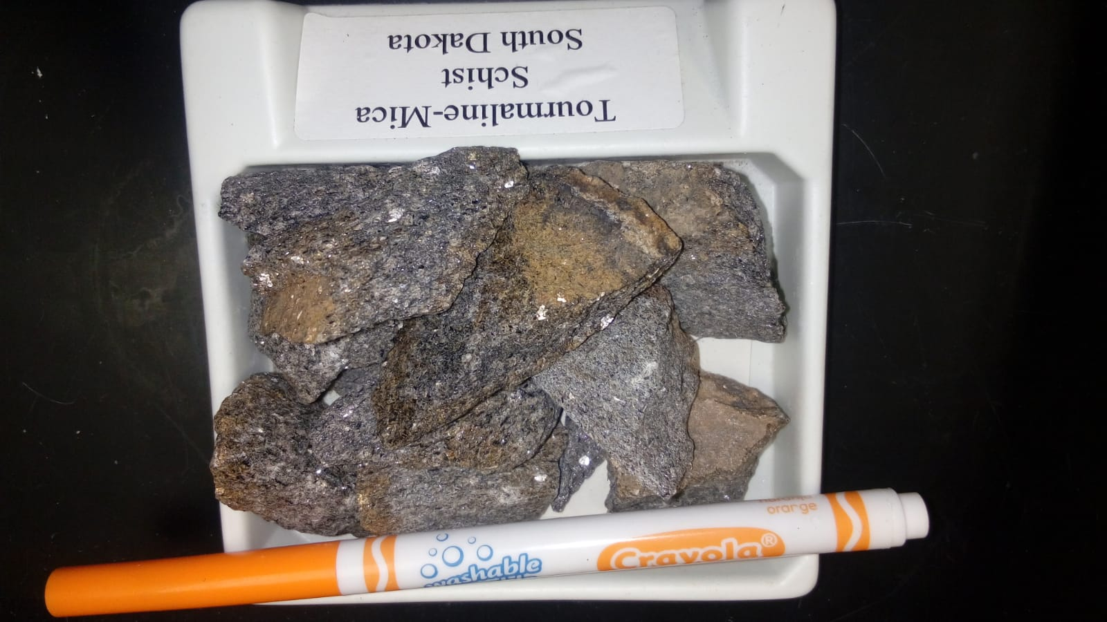

Black tourmaline in mica schist. Tourmaline is a crystal silicate mineral. It is a semi-precious gemstone and comes in a wide variety of colors. This black variety is known as schorl. Mica schists are common metamorphic rocks that can be recognized by their schistosity (fine planar alignment of minerals) and the presence of micas (silicate minerals).

**Graphite Schist**

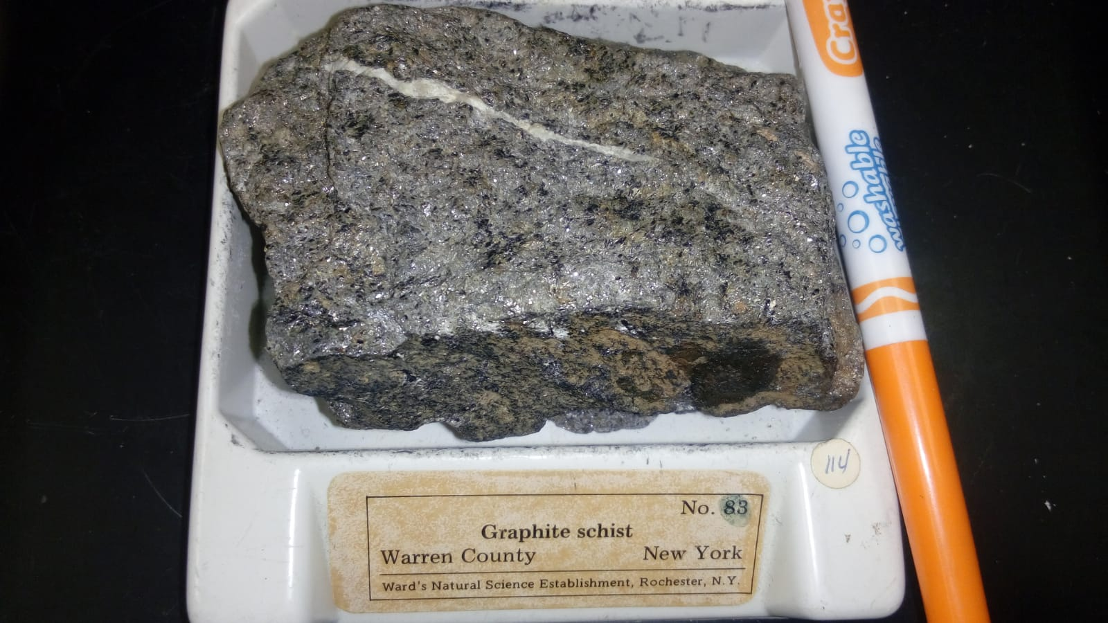

Graphite schists form as the result of metamorphism of organic matter. They are often recognizable because of the shiny luster of minute graphite grains. Actinolite is usually found in metamorphosed igneous rocks.